**Experiment No.**: 04

**Experiment Name:** Implementation of Newton Raphson method.

**Theory:** The Newton-Raphson method is an iterative numerical technique used to find approximate roots of a real-valued function. Starting from an initial guess, the method uses the function and its derivative to generate successive approximations that ideally converge to a root. Mathematically, the next approximation xn+1xn+1​ is calculated using the formula: $x_{n+1}=x_{n}-\frac{f(x_{n})}{f'(x_{n})}$

This technique is favored for its rapid convergence properties, especially when the initial guess is close to the actual root. However, it requires the function to be differentiable and the derivative not to be zero at the root.

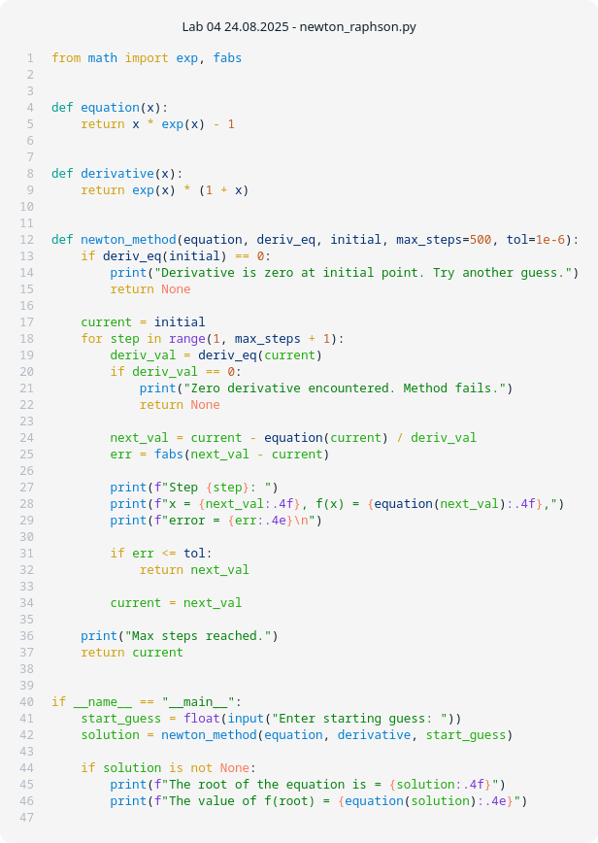**Program:**

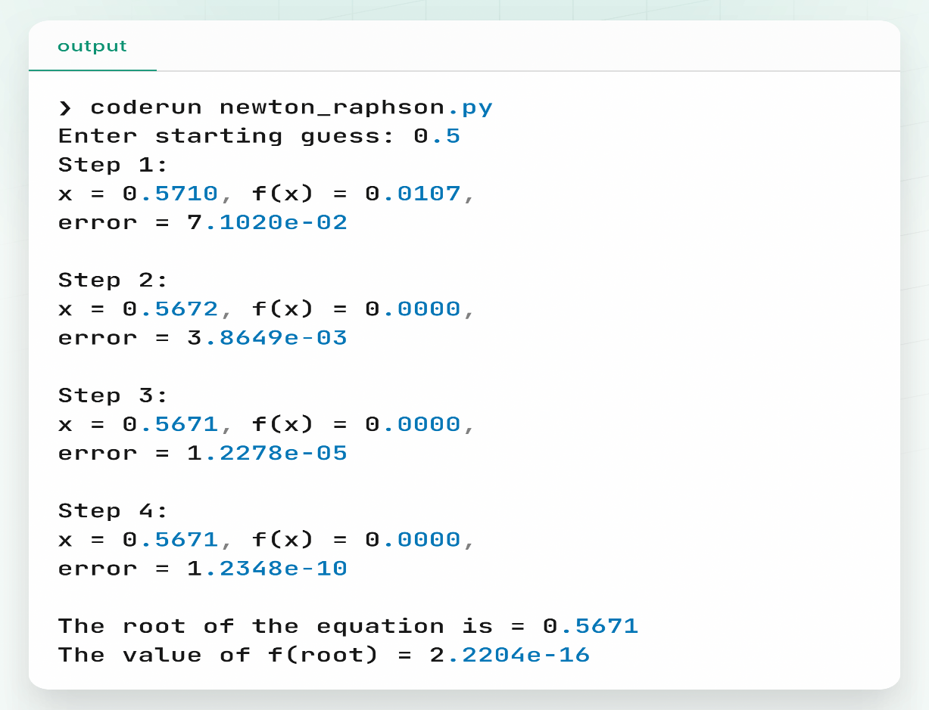**Output:**

**Discussion & Conclusion:**

The implementation of the Newton-Raphson method successfully demonstrated its efficiency in locating roots of nonlinear equations. Through iterative refinement, the method converged quickly to the root with minimal iterations, confirming its quadratic convergence behavior. The accuracy of the root depended largely on the choice of the initial guess; poor initial values could lead to divergence or convergence to an unintended root. Overall, this experiment highlights the Newton-Raphson method as a powerful tool in numerical root-finding, provided that the function’s derivative is computable and the initial estimate is judiciously chosen.

**Experiment No.**: 04

**Experiment Name:** Implementation of Newton Raphson method.

**Theory:** Newton-Raphson method is a root-finding algorithm that uses the tangent line at an initial guess to approximate the root of a function. By repeatedly applying the update formula:

$$x_{n+1}=x_{n}-\frac{f(x_{n})}{f'(x_{n})}$$

​the method improves the approximation of the root with each iteration. This approach leverages the derivative information, which guides the method towards the root more efficiently than methods that do not use derivative information. The method is particularly effective when the function behaves well near the root and the initial guess is sufficiently close.

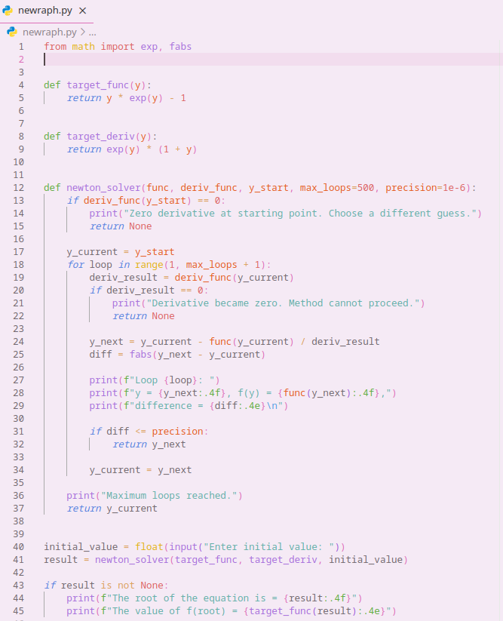**Program:**

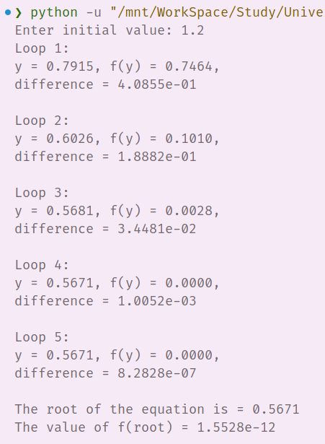**Output:**

**Discussion & Conclusion:**

The experiment confirmed that the Newton-Raphson method is an effective approach for solving nonlinear equations. The method rapidly zeroed in on the root, demonstrating fast convergence as predicted by its theoretical quadratic rate. Challenges arose when the derivative was zero or near zero, causing the iteration to fail or oscillate. Additionally, the initial guess's quality was critical to ensure convergence to the correct root. In conclusion, the Newton-Raphson method is a robust and efficient numerical technique for root finding, but careful attention must be paid to the function’s characteristics and initial conditions to avoid pitfalls.